Chapter 17, Problem 20.

Find the Fourier series for the signal in Fig. 17.58. Evaluate f(t) at t = 2 using the first three nonzero harmonics.

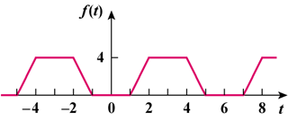

Figure 17.58
For Prob. 17.20.

